Lecutres 1-2:

Definitions
Medical Device:
The purpose is both for:
1. monitoring (diagnostic)
2. therapy.
The software can be considered an important part of the device (even a device itself). Indeed the certification deals also with the software, that has to be tested and certified.
The classification of medical devices is a ‘risk based’ system based on the vulnerability of the human body taking account of the potential risks associated with the devices. The classification rules are based on different criteria such as the duration of contact with the patient, the degree of invasiveness and the part of the body affected by the use of the device.
In Vitro Diagnostics (IVD):
IVD classification is based on the degree of health risk posed to an individual and public, and is related to the risk of an incorrect result arising from the use of the IVD.
Sensor ≠ Transducer
Transducer: “Any element that transforms an input signal into an output signal of different nature”
Sensor: “Any generic element, instrument or apparatus which is sensible to the changes of a physical variable and able to convert it into an (electric) (also electrical parameters) input signal for a system able to transmit information”
For example: an old mercury thermometer it’s of course a transducer, it changes the input from temperature to a value on a scale (length).
Sensors can be:
1. Passive
2. Active
3. Internal, eg: reference sensors
4. Non-contact, eg: IR camera

Measurement process

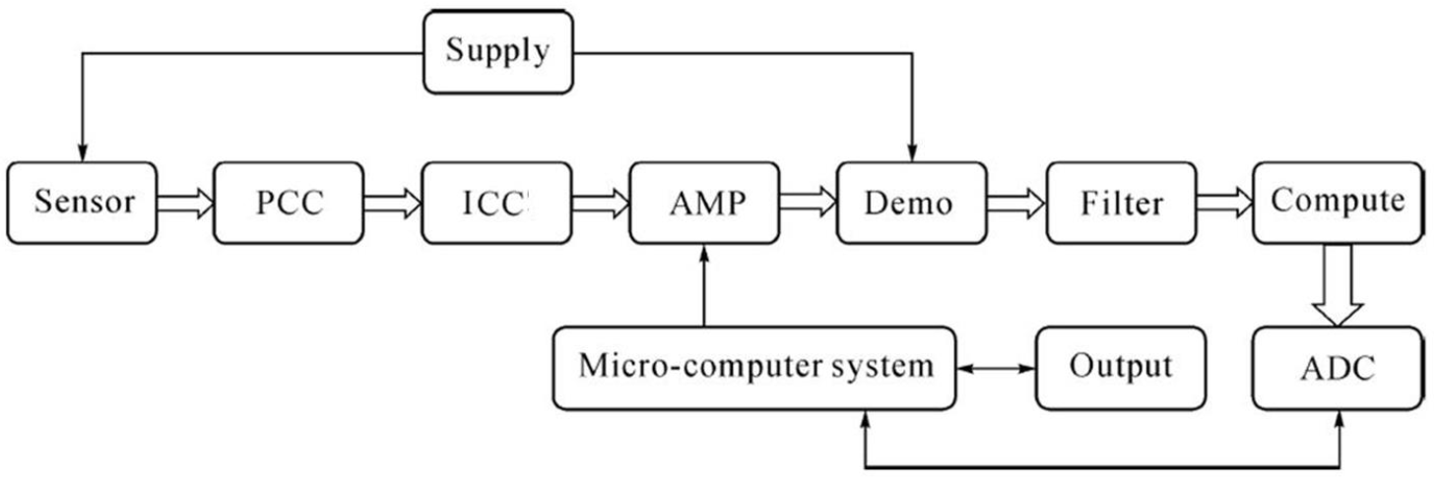
PCC = Parameter Converting Circuits The measured signal makes the sensors’ electrical parameters change, such as resistance, inductance and capacitance. In general, these changes are converted into voltage or frequency signals that are proportional to them. Therefore, there must be PCC. The commonly used parametric conversion circuits include:
- the bridge circuit (converting resistance, inductance or capacitance into voltage);
- current-voltage (IV) converting circuit;
- resistance, inductance, capacitance (RLC) oscillation circuit (converting resistors, inductors, capacitors into voltage or frequency digital signal), etc
Basically for example we go from R -> V / I / frequency
ICC = Impedance Converting Circuits Sensors can be regarded as a signal source with certain output impedance, while the following interface circuit has certain input impedance. In order to decrease the effects of the input impedance on the output signal, the impedance transformation is used in the design of the sensor interface circuit. By taking high input impedance amplifiers, the sensors’ high output impedance is converted into low output impedance. For example, in the design of measuring circuits of the voltage equivalent circuit using piezoelectric sensor, voltage amplifier has the effects of impedance conversion and signal amplification.
Output impedance has to be matched with the input impedance. We don’t want the circuit to influence the measurements.

Signal Conditioning Modules
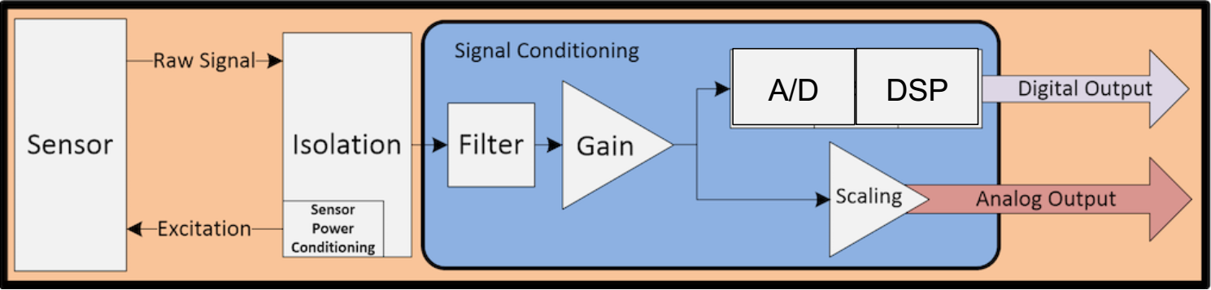
Signal conditioning includes many different processes, but some of the most common are amplification, isolation, filtering, excitation and linearization. A few examples of signals that may require a signal conditioner include: thermocouples, thermistors, RTD's, mag pickups and other proximity probes, LVDT, and strain gauges. A signal conditioner can also perform the functions of a signal converter by converting a raw signal from analog to a different form of analog or from analog to a digital signal.

Mechanical Ventilator: it’s measuring the pressure at the input of the patient, there’s also a flow sensor for both expiratory and inspiratory circuit. In this example the actuator is the gas delivery system. Of course there’s a feedback to check if the patient is receiving the correct values, and also a monitor to display these values.

Sensor’s classification
Which kind of stimulus is measured? To which physical phenomenon is sensible? What is the conversion mechanism? Which materials is made of? Which kind of modulation does it implement? In which fields/applications is it used? Which are its characteristics?
The conversion mechanism is how we convert the base stimulus to the output signal. The conversion phenomena: usually sensors have more than one conversion, but the last one is to V/I.

Example: thermistor
Measured variable: temperature
Structure: variable electrical resistance
Principle: thermo-electric conversion
Material: semiconductor
Applications: industry, medicine, etc.
Characteristics: transfer function: R t = Rt0 eβ(1/T - 1/T0) operating range: -55°C ÷ 200 °C
Highly nonlinear!

Conversion mechanism
Passive sensors:
a)“self-generating”
For example piezoelectric sensors.
Active sensors (Modulating):
b) impedance - resistive - capacitive - inductive
c) diode
d) transistor
Kind of Modulation: different basic structures that the sensor has, from an electrical point of view. It’s either:
1. Variable impedance sensors
2. Diode
3. Transistor
For example, we can have a mosfet (transistor) which can be used as a sensor, making the gate sensible to a substance (H+) The gate voltage changes with the change in concentration of [H+]. So with the change of pH.

Passive and active sensors
Self-generating (or passive) sensors do not need any additional energy source and directly generates an electric signal in response to an external stimulus; that is, the input stimulus energy is converted by the sensor into the output signal. The examples are a thermocouple and a piezoelectric sensor.
Modulating (or active) sensors require external power for their operation, which is called an excitation signal. That signal is modified by the sensor to produce the output signal. The active sensors sometimes are called parametric because their own properties change in response to an external effect and these properties can be subsequently converted into electric signals. It can be stated that a sensor’s parameter (property) modulates the excitation signal and that modulation carries information of the measured value.

Criterion | Classes | Examples
Power supply | Modulating (active)  Self-generating (passive) | Thermistor  Thermocouple
Output signal | Analog  Digital | Potentiometer  Position encoder
Operation mode | Deflection  Null | Deflection accelerometer Servo-accelerometer
Operation mode:
1. Deflection mode: a variable R inside a bridge
2. Null mode: we don’t measure directly, we measure something else, typically an electrical signal, in order to maintain the output at zero.”we measure the counter weight”. This way can be highly accurate, like servo mechanism, now employed in small sensors (mems). For eg: create an opposite force to maintain the mas in equilibrium.
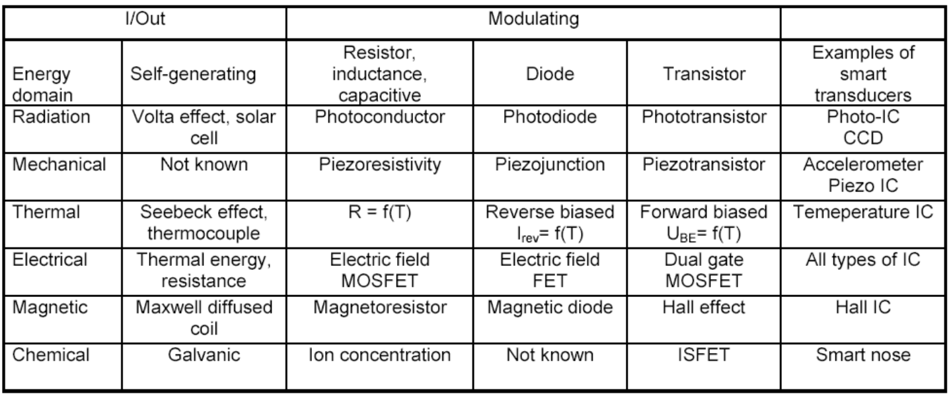
Energy domain: measured. Eg: solar cell: production: voltage, it’s a self-generating device. Also some photodiode can work without supply.
Smart transducer: they are “built to be smart” i.e. processing components in the same chip. For example CCD: matrix of light sensors, plus electronics to provide an image.

Usual sensors and sensing methods for common quantities
There are many sensors for one type of measure, the point is choosing the right one.
HOW TO USE A DIAPHRAM:
we can put strain-gauges on the diaphram, so that R is a function of the difference in pressure between two chambers. Or maybe we could have a capacitor, with one of his plates “moving” with pressure. Another way could be using fiber optic + photodetectors. The light changes its path (during the reflession) depending on how the diaphram is curved.

Integrated sensors
Array of sensors = integrated sensors made of many units (equal or very similar) with the same (or very similar) function. (For example ultrasonic probe)
Multisensors = constituted by different elements (sensors) each having different functions. For example the SHT1 which is both humidity and temperature. They both are on the same chip, but of course they are different physically.
Multifunction sensor = a single device that can provide different functions under different conditions.
For example the same wire is used to different things. Same structure employs a different function with the same sensor. This is useful to compensate temperature-related errors.

Integration of sensor and conditioning unit on a single chip
Levels of data manipulation:
- First level: Automatic correction of the raw signal: offset balance, temperature drift compensation, etc.
- Second level: signal amplification and conversion
- Third level (“smart sensors”): incorporates a microprocessor and a memory for different functions as: Signal processing and recording; Static errors compensation; auto-calibration and testing; Automatic selection of range of measurement; Calculation of average values, tolerance, etc. Compensation of time-dependent instabilities

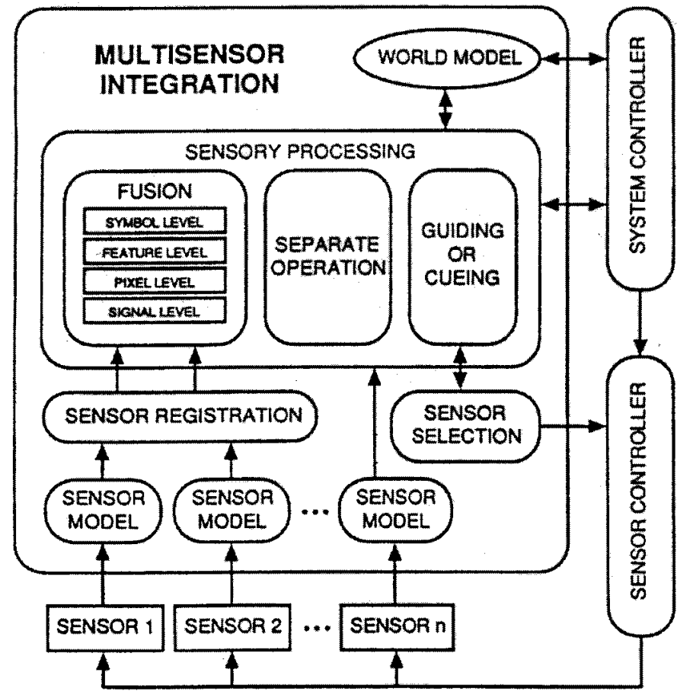
Sensor model: we have to process the sensors output differently. But this is not the best we can do, we can do fusion.

Sensor fusion
Sensor Fusion is the combining of sensory data such that the resulting information is in some sense better than would be possible when these sources were used individually.
Advatanges of sensors fusion:
Robustness and reliability: Multiple sensor suites have an inherent redundancy which enables the system to provide information even in case of partial failure.
Extended spatial and temporal coverage: One sensor can look where others cannot respectively can perform a measurement while others cannot.
Increased confidence: A measurement of one sensor is confirmed by measurements of other sensors covering the same domain.
Reduced ambiguity and uncertainty: Joint information reduces the set of ambiguous interpretations of the measured value.
Robustness against interference: By increasing the dimensionality of the measurement space (e. g., measuring the desired quantity with optical sensors and ultrasonic sensors) the system becomes less vulnerable against interference.
Improved resolution: When multiple independent measurements of the same property are fused, the resolution of the resulting value is better than a single sensor's measurement.
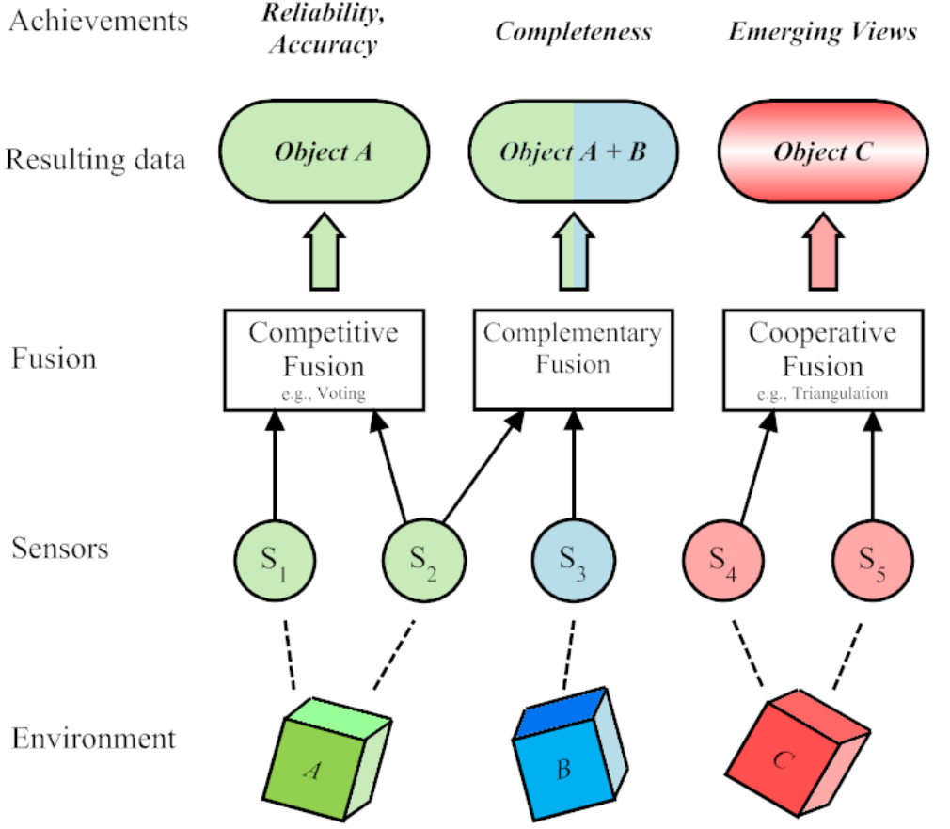
A sensor configuration is called complementary if the sensors do not directly depend on each other, but can be combined in order to give a more complete image of the phenomenon under observation. This resolves the incompleteness of sensor data. An is the employment of multiple cameras each observing disjunct parts of a room.
Sensors in a competitive configuration have each sensor delivering independent measurements of the same property. Competitive configurations are used for fault-tolerant and robust systems. An example would be the reduction of noise by combining two overlaying camera images.
A cooperative sensor network uses the information provided by two independent sensors to derive information that would not be available from the single sensors. An example is stereoscopic vision.
Fusion is smarter than simple integration! In integration you take the data from different sensors, but it uses like they are, without considering the environment etc. It doesn’t pass through a model, with fusion they pass through a model of the environment.
Multisensor integration means the synergistic use of sensor data for the accomplishment of a task by a system. Sensor fusion is different to multisensor integration in the sense that it includes the actual combination of sensory information into one representation format.
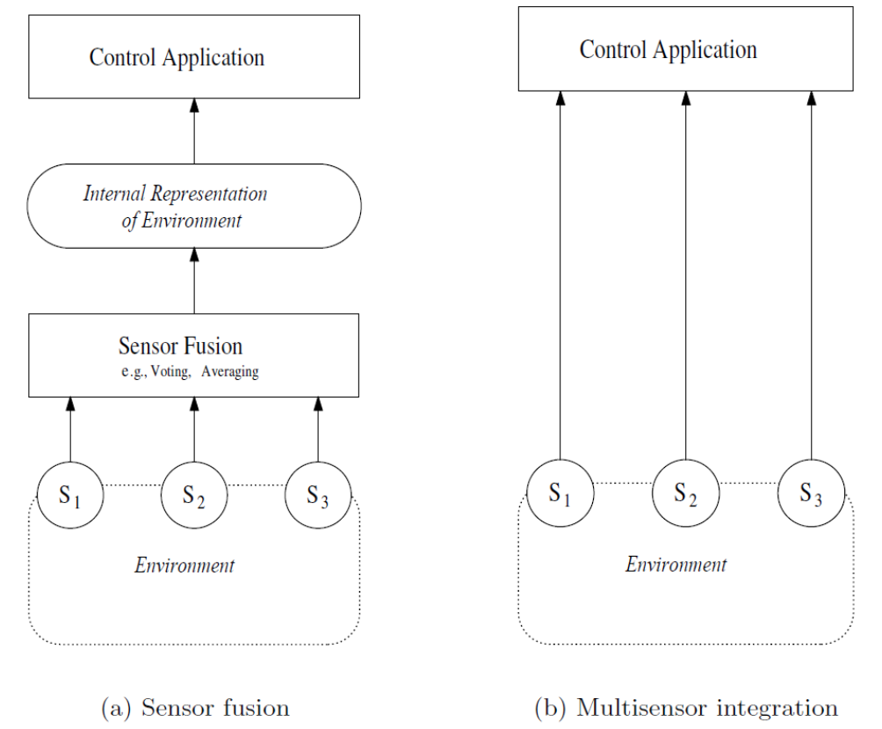
Sensor fusion: Kalman filter on IMU (Inertial Management Unit) data
The MPU-9250 is a 9-axis MotionTracking device that combines a 3-axis gyroscope, 3-axis accelerometer, 3-axis magnetometer and a Digital Motion Processor™ (DMP) all in a small 3x3x1mm package
This is an example of multisensors device with sensors fusion. The Kalman filter is the “Model” that combines the data (3 vectors) to provide the displacement of the system.

Static characteristics
- I/O relationship
- Input span
- FSO: Full scale output
- Sensitivity
- Accuracy
- Precision
- Repeatability
- Reproducibility
- Linearity
- Hysteresis
- Resolution

Input (x) – output (y) relationship
Linear: y = a + b x
Logarithmic: y = a + b ln x
Exponential: y = a exp (k x)
Power: y = a + b xk

Input range (“Span”)
Range of values that can be converted by a given sensor For large ranges, it is expressed in decibel (dB)
dB: log of ratio between power or voltages
Power ratio: 1 dB = 10 log (P2/P1)
Voltage ratio: 1 dB = 20 log (V2/V1)

Full Scale Output (FSO)
Algebric difference between the output electric signal obtained when the input stimulus is maximum and the output electric signal obtained when the input stimulus is minimum.

Sensitivity
Slope of the input-output relationship. dy/dx (also for a given x).

Accuracy
Ability of a sensor to provide a measurement close to the real value of the measurand.
Error = result of the measurement – real value (expressed as absolute value or percentage value with respect to the true value or to FSO)

Precision
Ability of a given sensor to provide the same result under repeated measurements of the same quantity in the same conditions. It represents a condition necessary, but not sufficient for accuracy.
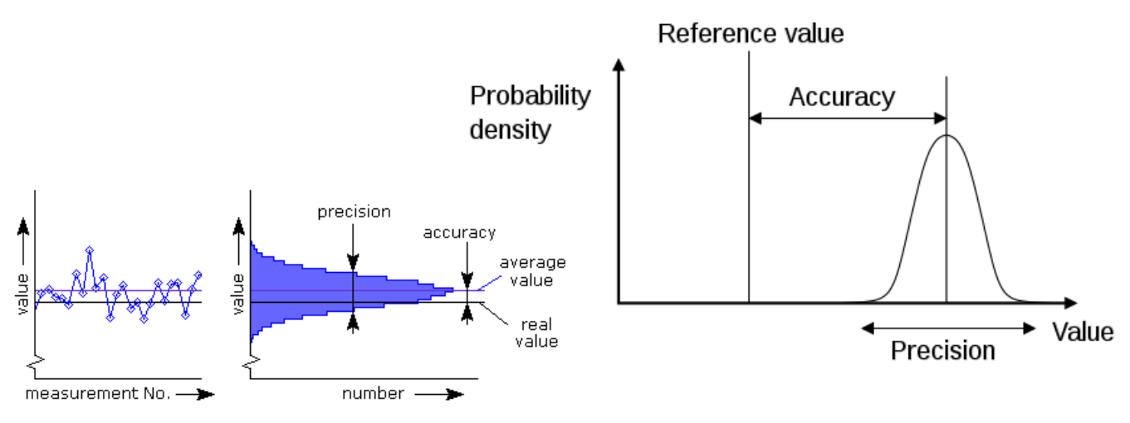

Repeatability
- Same method
- Same condition
- Short time interval
Degree of vicinity between successive results obtained by the same method under the same conditions and in a short interval of time. Quantitatively, repeatability is the minimum value that exceeds, with a given probability (e.g. 95%) the absolute value of the difference of two consecutive measurements obtained in the above cited conditions. It represents a condition necessary, but not sufficient for accuracy.
Like, q95, it’s not literally the worst case scenario but it’s close.
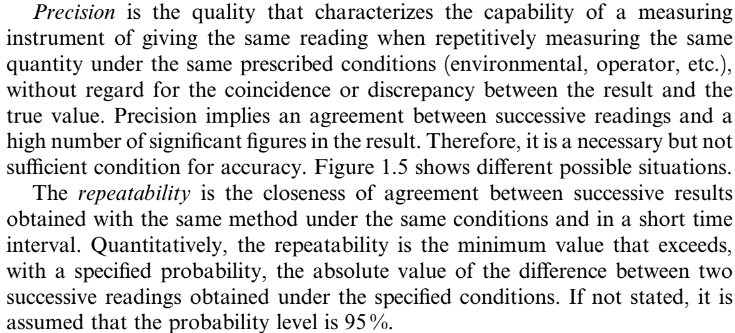

Reproducibility
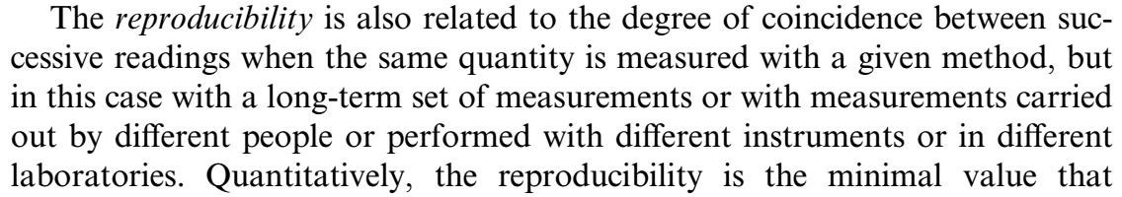
Quantitatively, reproducibility is the (minimum) value that exceeds, with a given probability (e.g., 95%) the absolute value of the difference between two measurements obtained in the above cited conditions.
Il valore differenza tra due misure successive che è sempre vero con 95% di probabilità. Nel senso che: se ho due misure, so con 95% di sicurezza che saranno diverse di almeno X.

Linearity
Vicinity of the calibration curve of a given sensor to a specified straight line, expressed as percentage of FSO, i.e. the maximal deviation of each calibration point from the corresponding point on the specified straight line
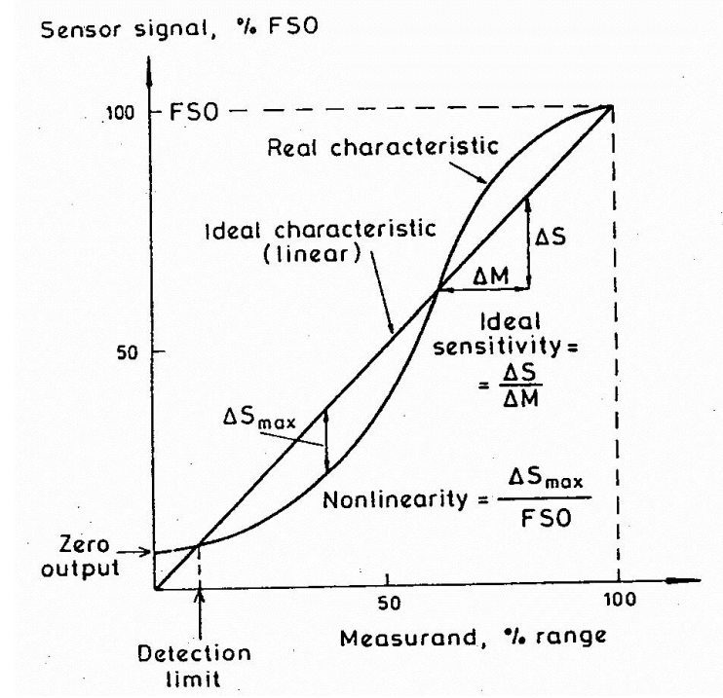
There are actually different ways to express how much the calibration curve is similar to a specified straight line. It could be a % of FSO or in terms of difference. NL=Dmax/FSO is a way. It means that we look for the maximum difference in the output with the straight line, in respect to the FSO. For example, 3% would be good, and we don’t use the real calibration curve because it’s more convinient not to.
Linearity describes the closeness between the calibration curve and a specified straight line. Depending on which straight line is considered, several definitions apply.
(a) Independent Linearity. The straight line is defined by the least squares criterion. With this system the maximal positive error and the minimal negative error are equal. This is the method that usually gives the ”best'‘ quality.
(b) Zero-Based Linearity. The straight line is also defined by the least squares criterion but with the additional restriction of passing through zero. (b=0)
(c) Terminal-Based Linearity. The straight line is defined by the output corresponding to the lower input and the theoretical output when the higher input is applied.
(d) End-Points Linearity. The straight line is defined by the real output when the input is the minimum of the measurement range and the output when the input is the maximum (FSO).
(e) Theoretical Linearity. The straight line is defined by the theoretical predictions when designing the sensor.

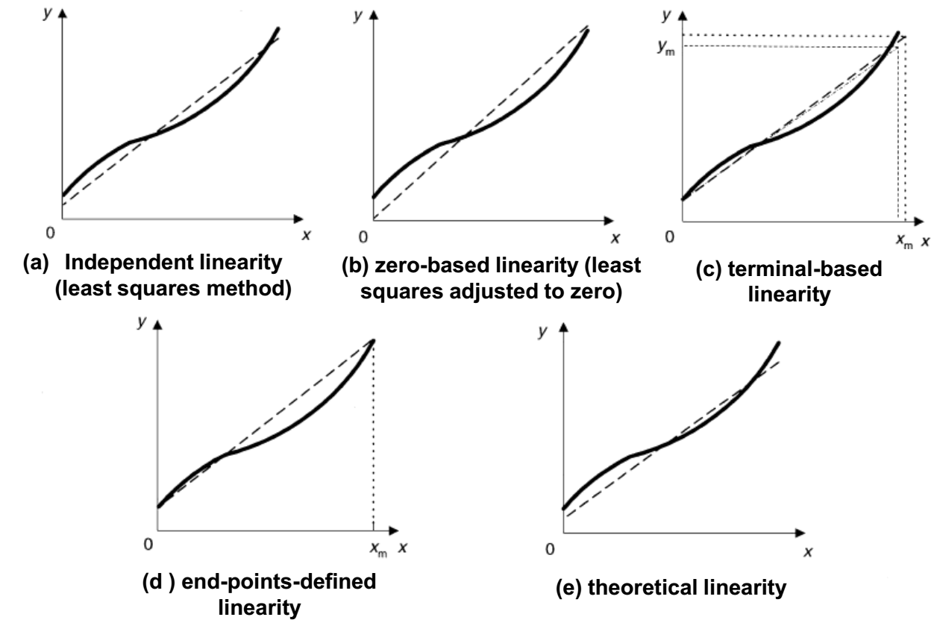

Hysteresis
Maximal difference in the output, when the output is firstly obtained with increasing measurand, then with decreasing measurand (for each value of the measurand in the specified range); it is usually expressed as percentage of FSO
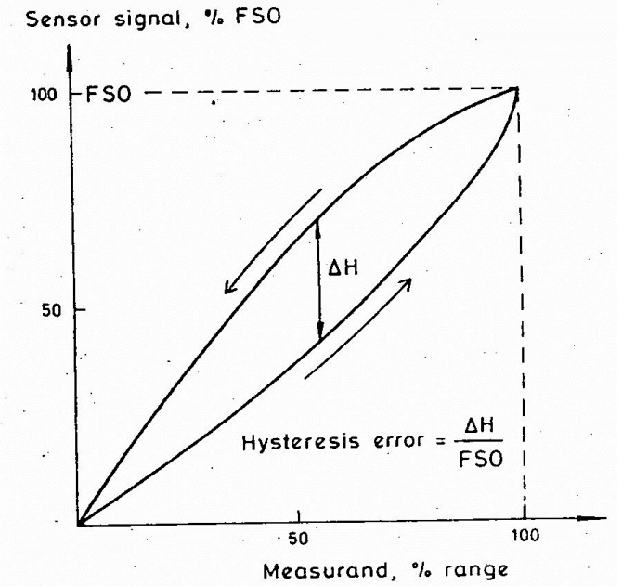

Resolution
Minimum increment of the measurand that can be detected. A clock with only hours has a low resolution.
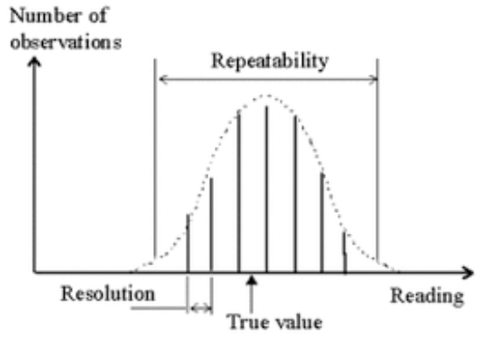
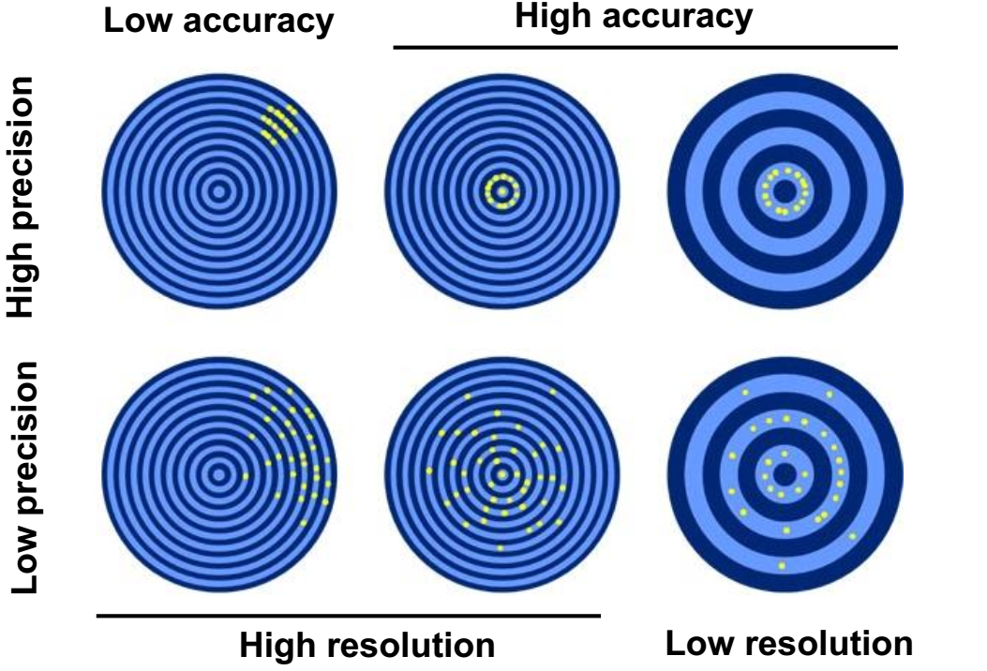
We can have systematic errors, meaning high precise on high resolution instruments, but with a low accuracy.

Single- and double-point calibration
In one-point-calibration we assume that it passes through zero. In two-point-calibration it just passes through the 2 points. Then of course we get the inverse relationship, because we want to know what was the input, after we have read the output signal.
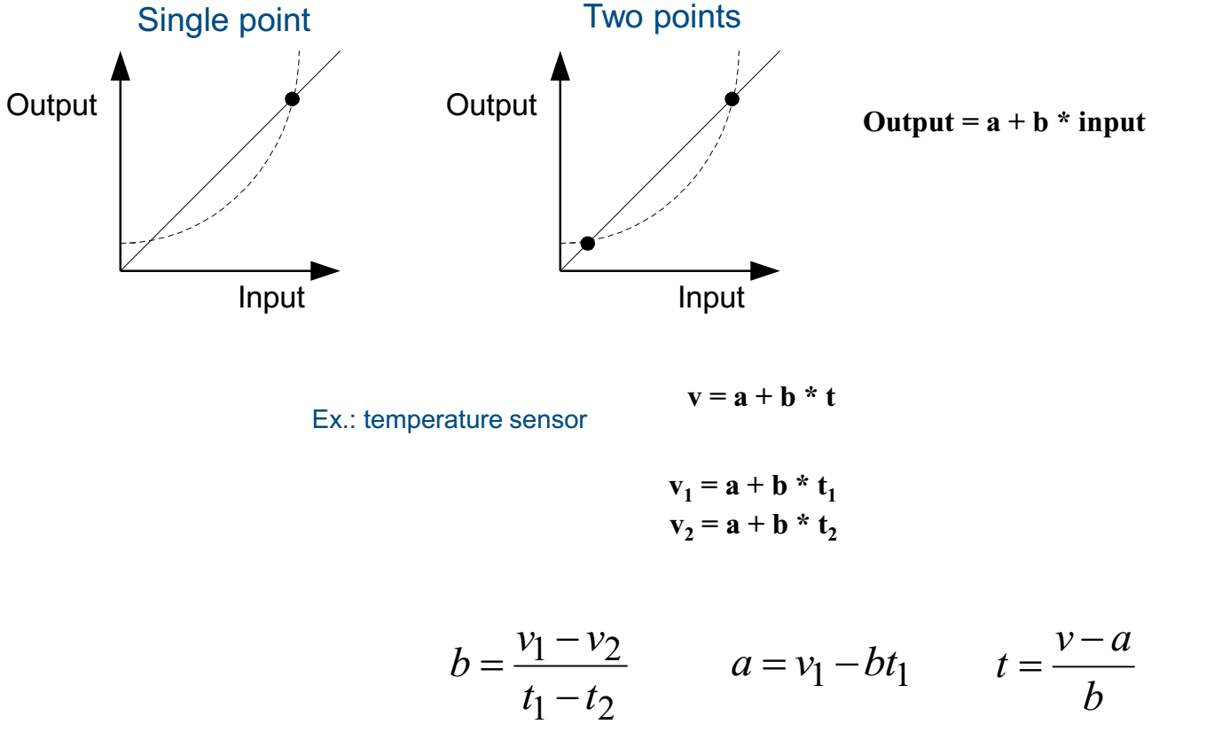

Calibration by linear regression
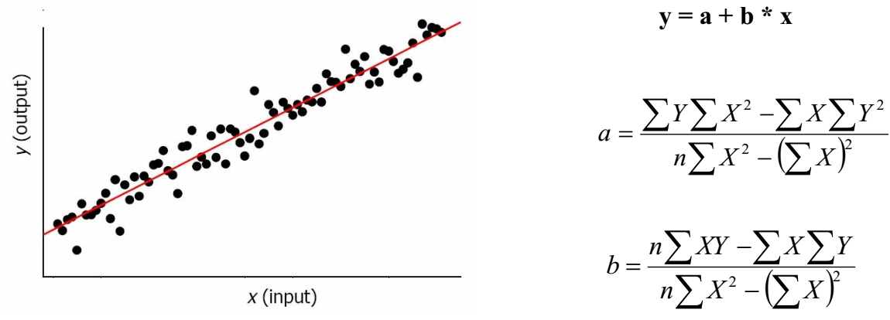
Is this indipendent-linearity?

Calibration error
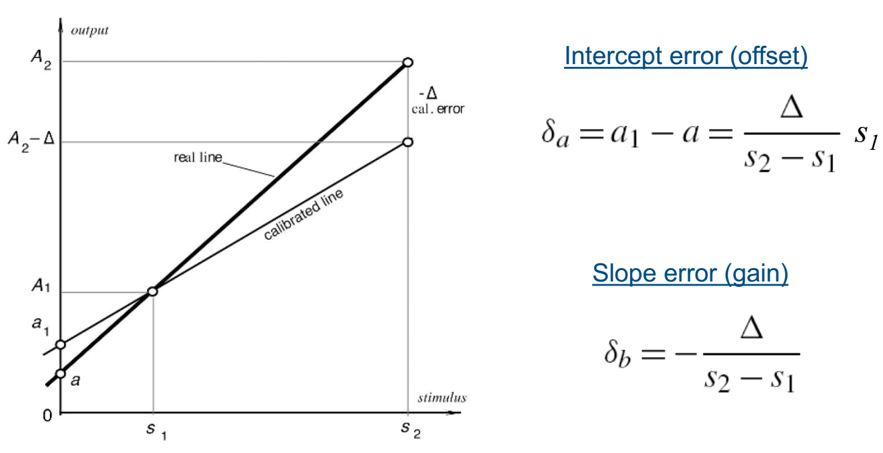

Calibration

Zero (“offset”)
Sensor output when the measurand has a nil value
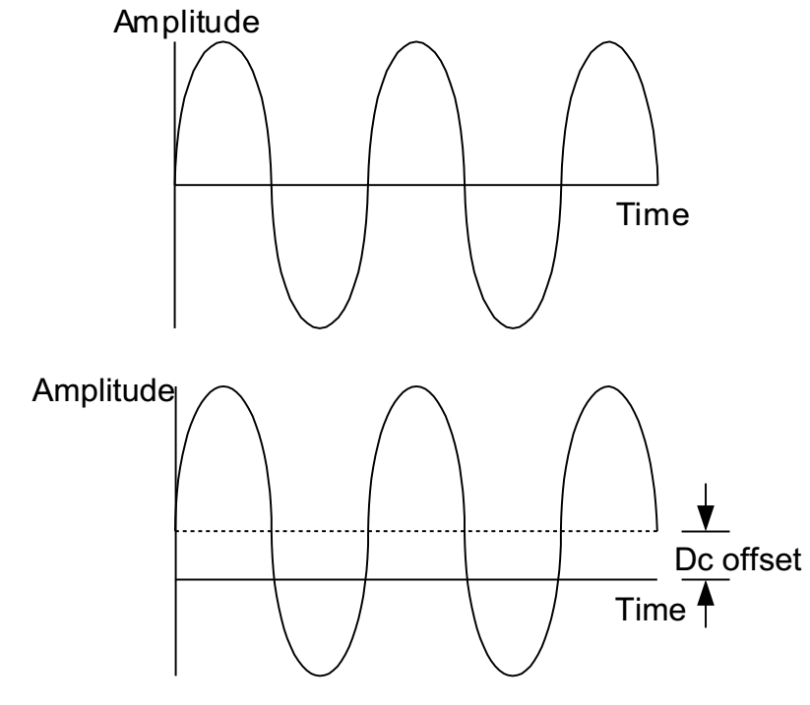

Full-Scale Input (Span)
Maximum value of the measurand
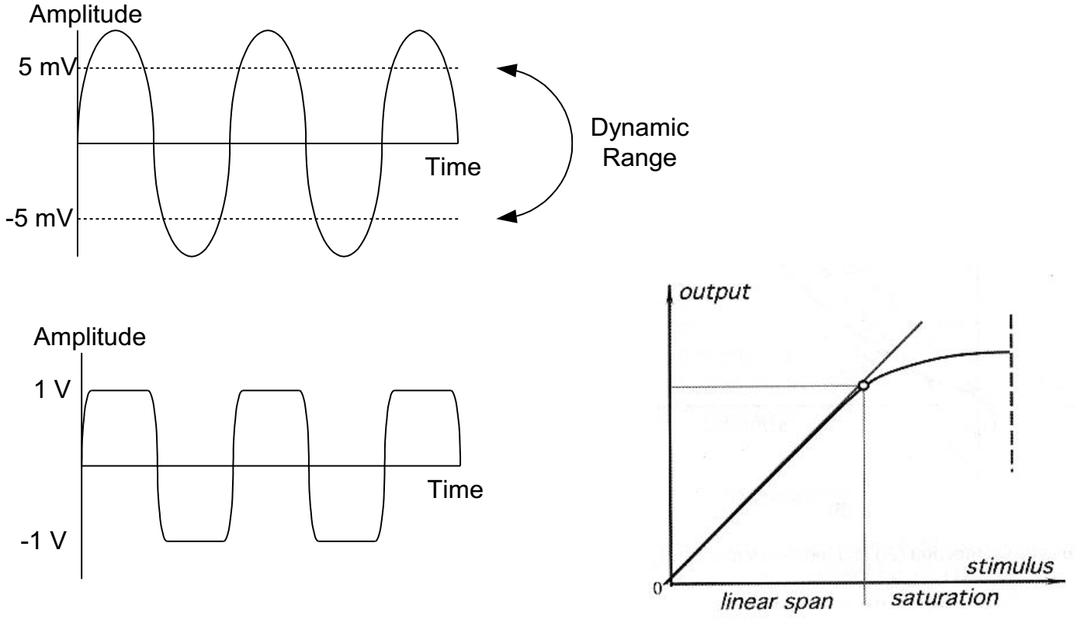

Drift
Zero variation under specific conditions (e.g., changing temperature, ageing, disuse, etc.)

Sensitivity Shift
Variation of sensitivity under specific conditions (see above)
Accuracy is an indication of the correctness of a measurement. Because at a single measurement the precision affects also the accuracy, an average of a series of measurements will be taken. The uncertainty of measuring instruments is usually given by two values: uncertainty of reading and uncertainty over the full scale. These two specifications together determine the total measurement uncertainty. These values for the measurement uncertainty are specified in percent or in ppm (parts per million) relative to the current national standard. 1% corresponds to 10000 ppm. The specified uncertainty is quoted for specified conditions (e.g., temperature) ranges and for certain time period after calibration.
Uncertainty relative to reading
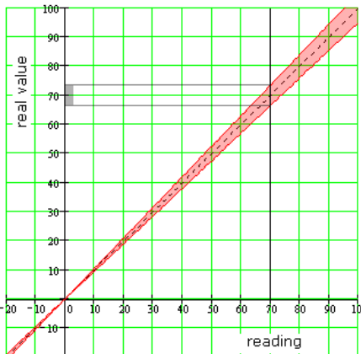 (An indication of a percentage deviation without further specification usually refers to the reading). Tolerances of voltage dividers, the exact gain and absolute deviation of the readout and digitization cause this inaccuracy.  A voltmeter which reads 70,00 V and has a "±5 % reading" specification, will have an uncertainty of 3,5 V (5% of 70 V) above and below. The actual voltage will be between 66,5 and 73,5 volt.
Uncertainty relative to full scale
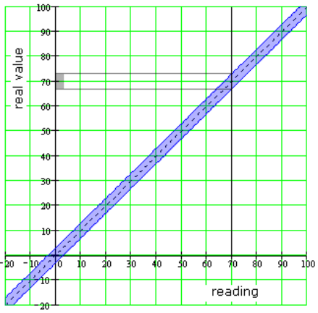This type of inaccuracy is caused by offset errors and linearity errors of amplifiers. And with instruments that digitizes signals, by the non-linearity of the conversion and the uncertainty in AD converters. This specification refers to the full-scale range that is used. A voltmeter may have a specification "3 % full scale". If during a measurement the 100 V range is selected (= full scale), then the uncertainty is 3 % of 100 V = 3 V regardless of the voltage measured. If the readout in this range 70 V, then the real voltage is between 67 and 73 volts.
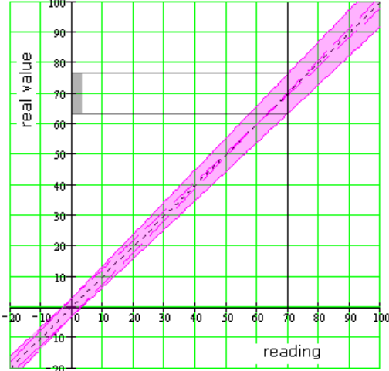
Calculation of TOTAL measurement uncertainty The specification of the tolerance of the reading and the full scale together determine the total measurement uncertainty of an instrument. In the following calculation example the same values are used as in the examples above: Accuracy: ±5 % reading (3 % full scale) Range: 100 V, Reading: 70 V The total measurement uncertainty is now calculated as follows: 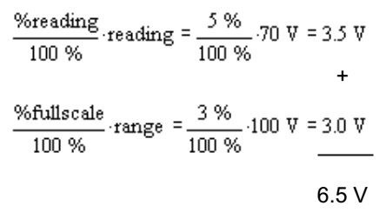
In this situation, a total uncertainty of 6.5 V up and down. The real value should be between 63.5 and 76.5 volts.

Calibration: example
Typical characteristics of pressure sensors:
• P nom = nominal pressure range;
• P max = maximal pressure that the sensor can sustain
• a = TCR (Temperature coefficient of resistance)
• V OS = offset voltage
• aVos = offset TCR (offset change with temperature, millivolt/Kelvin);
• S = Sensitivity;
• aS = sensitivity TCR (sensitivity change with temperature)
For an uncalibrated sensor, the relationship between output differential voltage (VDIFF), pressure (P) and temperature (T) is the following:
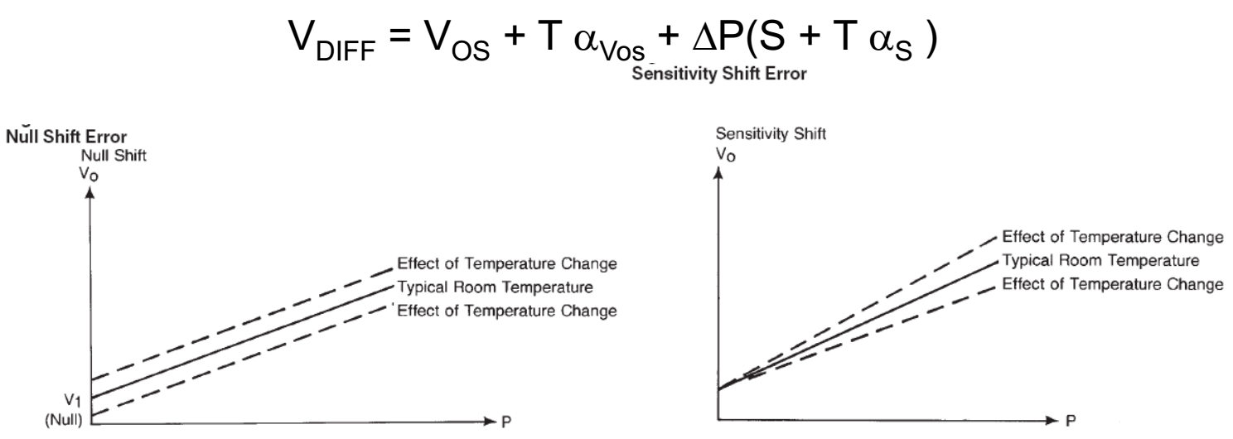
In this example, both as and avos represents the disturbance effects on the measure. The temperature can both change the sensitivity and the offset in this case. Combining the two shifts we obtain the uncertanty of the calibration line.
???????????????????????????????????????? forse l’idea è che noi non conoscendo la temperatura non sappiamo come varia la misura, e quindi abbiamo una incertezza. Cioè, il risultato ci varia con la temperatura, però se non ne teniamo conto, perché non abbiamo ricalibrato per questa nuova temperatura, allora abbiamo valori che corrisponderebbero ad ingressi diversi.

Biocompatibility
Biomedical sensors implanted in animal or human bodies or in direct contact with tissue in vitro must be non-toxic, nonallergenic, non-irritating, non-genetic toxic and noncarcinogenic. Besides, they are not supposed to make the animal or human tissues, blood and immune systems produce any adverse reaction. Sensors should be compatible with the chemical composition in organisms. Therefore, the biocompatibility of the material is a priority to be considered.
Generally speaking, in the design of implantable biomedical sensors, the following factors should be considered:
- Sensors are not supposed to be corroded or toxic. In this way, they must be compatible with the chemical composition in organism.
- The shape, size and structure of sensors implanted in the human body should adjust to the anatomical structures of the measuring object. What is more, sensors should never injure the tissue.
- Sensors should be solid enough. When implanted, the sensor should not be damaged.
- Sensors must be electrically insulated. Once the sensor is damaged in a human body, it should be certain that the voltage imposed on the human body is under the safe security value.
- Sensors should neither place physical activities a burden, nor interfere with the normal physiological function.
- The in vivo sensors used for long term implantation should not cause any vegetation.
- The structure of the sensor should be easily disinfected.

Invasive / non-invasive measurement systems
Invasive measurement uses methods that will influence or even injure the objects while the non-invasive measurement will have tiny or non-influences on the objects. For example, there are many methods to detect cancers, including gene detection, blood detection, PET-CT, e-Nose and so on. Among these methods, only the electronic nose is non-invasive as it just collects the patients’ exhaled without any injures.

Wired / Wireless measurement systems
In recent years, wireless measurement has developed very fast and is being used in more and more fields such as communication technology, biomedical fields and so on. For example, an RFID-Based Closed-Loop Wireless Power Transmission System has been reported in use in biomedical field, especially for inductively powering implantable biomedical devices. In this system, the transmitter and receiver coils are in a wireless power transmission. Any changes in the distance and misalignment will cause a significant change in the received power. As it is a closed loop, this change will get detected. This system can be used on the implanted chips to better detect diseases.

